

St James’ CE Primary School,
Haslingden

HANDWRITING POLICY
Written By | A Humberstone
Date | September 2025
Approved by FGB
Date of Review | September 2026

Growing in God’s love; learning as we go.

ENDURANCE FORGIVENESS PEACE
FRIENDSHIP TRUST KOINONIA
THANKFULNESS

Mission statement
To provide a high quality education for all of our children with a Christian environment.
Vision
We are a safe, loving, supportive Christian family which values each child’s individuality and uniqueness created in the image of God. We nurture the talents given by God to inspire pupils to achieve and succeed, and foster a sense of awe and wonder of God’s world:
- Form foundations of lifelong faith through Gospel values, and sincere meaningful prayer.
- Guide pupils to determine their own personal moral values, and a respect and understanding of other races, religions and ways of life.
- Develop future citizens who cherish the word in which they live and their responsibilities within it.
- A curriculum which has a breadth of experience and equality of opportunity for all.
Aims
At St James’ we aim to:
- ensure all pupils develop a clear, legible, and increasingly fluent handwriting style.
- establish consistency in the teaching of handwriting across the school.
- embed cursive letter formation in Reception to support early writing.
- provide clear progression and high expectations in handwriting.
- raise the profile and importance of good presentation across all areas of the curriculum.
- provide support and appropriate challenge for all learners, including those with additional needs.
- To foster pride in pupils' written work through the development of a neat and legible style.

Teaching and Learning

Handwriting is a key component in writing fluency and legibility. The Writing Framework (2025) states that “Pupils should be taught handwriting precisely, in a clearly sequenced progression, starting from reception, to support their gradual acquisition of skills.” A consistent whole-school approach supports children in developing these essential transcription skills. Adults in school play an important role in modelling high standards of presentation and encouraging high expectations. They are responsible for demonstrating good practices, ensuring that all children understand and follow handwriting expectations.
Teaching strategies include:
- Children practise writing letters daily as part of phonics in EYFS and KS1.
- Large-scale (gross motor) letter formation in the air or on whiteboards.
- Focus on correct pencil grip and posture.
- Multisensory approaches (e.g., sand trays, textured letters) to aid kinaesthetic learning.
- Modelling: Teachers will model handwriting styles explicitly during lessons, ensuring pupils observe correct techniques.
- Peer Feedback: Incorporating opportunities for peer assessment with a focus on handwriting.
- Targeted Interventions: Identifying pupils who require additional support and providing tailored interventions.
- Use of Technology: Including digital resources and apps as supplementary tools to enhance handwriting skills.

Progression of Skills

At St James C of E Primary School, the structured handwriting programme, Nelson Handwriting, is used for the teaching of handwriting across the school. This begins in the Early Years Foundation Stage (EYFS) with a focus on developing fine motor skills and correct letter formation. As pupils move through Key Stage 1 (KS1) and Key Stage 2 (KS2), the curriculum becomes increasingly complex, introducing connected writing and varying degrees of fluency and speed.

- Early Years Foundation Stage (EYFS):
  - The Nelson handwriting programme is introduced through short interactive videos, with accompanying work books to allow the children to practice forming each individual letter.
  - The 'Read Write Inc.' (RWI) phonics programme, which incorporates handwriting through letter formation is used alongside The Nelson Handwriting programme as children learn each letter sound.
  - Utilise multi-sensory approaches to promote fine motor skills, including activities like sand writing, finger painting, and use of clay.
  - Focus on correct grip, posture, and movement capabilities through guided activities that support cursive handwriting style.

By the end of the foundation stage, most children are able to use a pencil, holding it effectively to form recognisable letters, most of which are correctly formed using cursive handwriting.
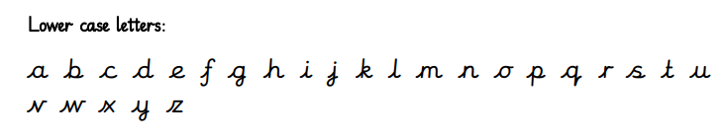
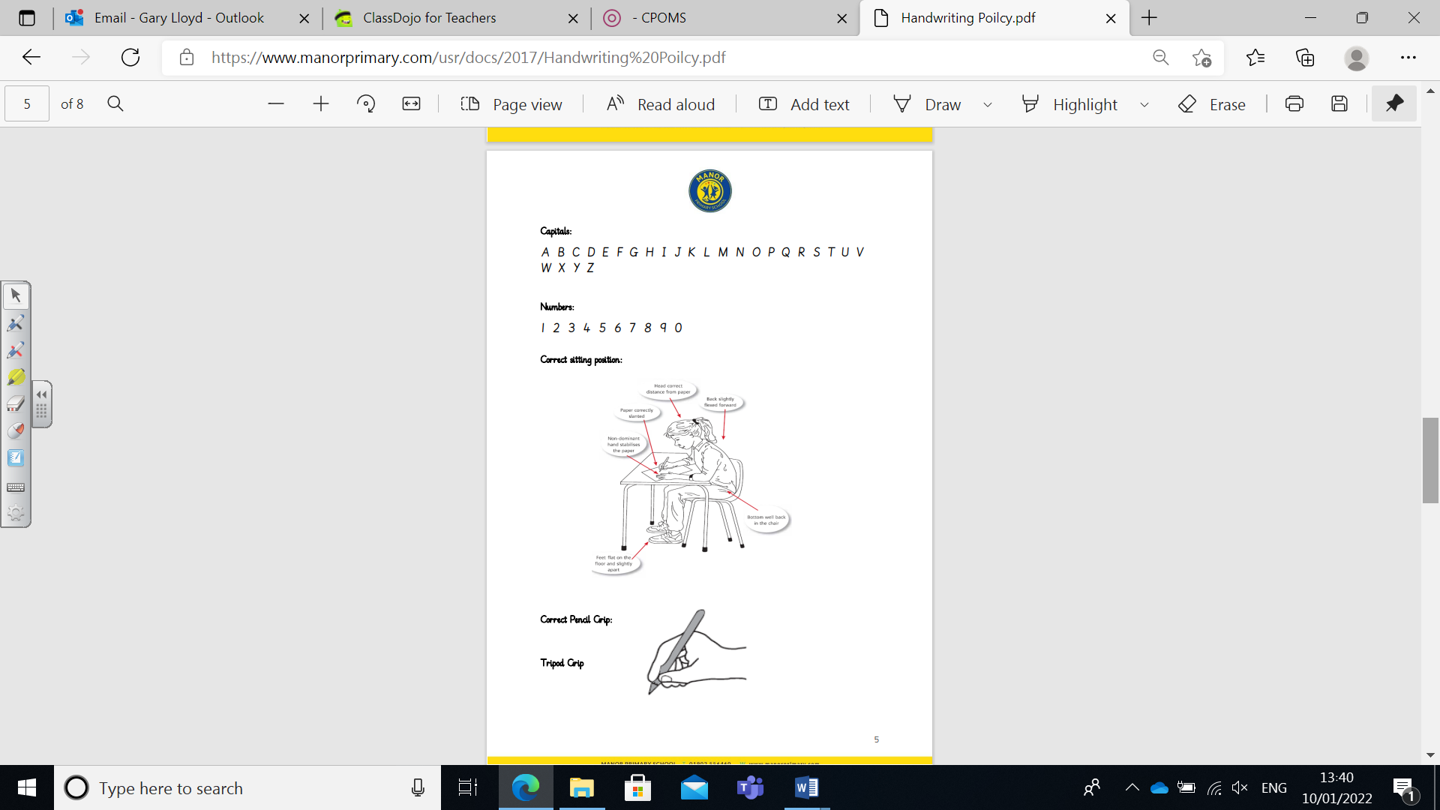

- Key Stage 1 (KS1):
  - Children will continue to use the Nelson Handwriting programme to solidify their understanding of letter formation, focusing on cursive handwriting from the outset.
  - Consolidate the habit of proper letter formation and connecting letters, reinforcing these in every writing exercise conducted in class.
  - Regular, targeted lessons with daily practice sessions to reinforce skills, incorporating the use of lined paper for structure.
- Key Stage 2 (KS2):
  - Further development of cursive handwriting with emphasis on fluency, speed, and personal style.
  - Teachers will integrate handwriting practice in subjects across the curriculum to enable real-life application of skills.
  - Encourage neat handwriting for greater efficiency and enhanced presentation, promoting pride in their written work.

Assessment and Outcomes for Children

Assessments will be integral in monitoring handwriting development. Regular formative and summative assessments will evaluate pupil progress and identify areas needing support. The assessment of handwriting across the school will include:

- Handwriting skills across all subjects being regularly assessed, with feedback provided to pupils.
- English Subject Leader and/or Senior Leadership Team monitor handwriting and presentation in books from across the curriculum regularly and provide feedback to teachers.
- Yearly Summative Assessments, evaluate progress to determine if children are meeting expected standards and to inform future planning.
- Teachers model high standards of handwriting at all times. All staff follow the handwriting policy when writing comments in children’s books.
- Children are rewarded by SLT with a handwriting pencil/pen if handwriting is consistently good across a range of books.
- Display Work: High-quality handwriting will be showcased throughout the school to celebrate achievements and encourage standards.
Intervention and Support
Children’s progress will be monitored through regular assessments and observations. Any child who is falling behind will receive targeted intervention programmes, such as small group sessions led by a teaching assistant or teacher, focusing on individual needs. Tailored resources and activities designed to enhance handwriting skills will be utilised for struggling pupils. We aim to engage parents in their child's handwriting development by providing suggestions for home practice and resources.

Equal Opportunities and Special Needs

At St James C of E Primary School, we are committed to ensuring that all children, including those from disadvantaged backgrounds and with special educational needs and/or disabilities (SEND), are given the same opportunities to progress and succeed in developing their handwriting skills. This includes:
- Ensuring that all materials and resources are accessible to pupils with different abilities and needs.
- Pencil grips, thicker pencils, triangular pencils and wider lines will be used by children who experience problems writing.
- Differentiating lessons to cater to diverse learning styles, ensuring that every child is included and supported.
- Providing targeted support and appropriate resources for left-handed children to facilitate their handwriting development effectively.
- Recognising and addressing any barriers to learning that individual pupils may face, including those with special educational needs and disabilities (SEND).

Handwriting and Parental Involvement

At St James’ CE Primary School, we believe that parents play a vital part in their child’s education and as such, we attempt to involve them at every level of their child’s learning in English. To facilitate this, we will aim to provide resources, tips, and guidance for parents on how to assist their children with handwriting practice at home. We encourage open communication between school and home and any concerns or queries can be discussed with the class teachers.

